

Operator’s Manual of Laser Embedded Software

4750 Longley Ln #205

Reno, NV, 89502

Phone 775-348-4820

www.crystalaser.com

Contents

**Chapter 1 Overview** 3

**1.2** **Environmental requirements** 3

**1.3** **Software running** 3

**Chapter 2 Laser Control Panel** 5

**2.1** **Read laser status from serial port.** 5

**2.2** **Setup laser through the serial port.** 5

**Chapter 3 Command-based Control** 11

**Chapter 4 Laser Controller on Windows** 12

**4.1** **Connection.** 12

**4.2** **Laser status.** 13

**4.3** **Output power setup** 13

**4.4** **Maximum\Minimum power setup** 14

**4.5** **Power calibration** 14

1. **Chapter 1 Overview**
   1. **Laser embedded software introduction**

Laser embedded software through a chip-level control programming to achieve effective controls for laser devices of Crystalaser, according to the user’s different requirement of the completion of laser monitoring and control tasks.

The system includes control boards and supporting software. The manual describes how to use the software to complete the laser monitoring and control.

* 1. **Environmental requirements**

1. Windows XP operating system and above.
2. CPU, above PIII or PV recommended.
3. Memory, above 1G recommended.
   1. **Software running**

This software provides a control panel through a ***Serial Port*** to monitor and control the laser devices. Users can use any serial port monitor to access the software, recommend Serial Monitor-Arduino, Serial Monitor-Chrome, both are free.

COM setting: user can find the laser connected COM by right-clicking This PC->Manage->Device Manager->Ports (COM & LPT), as shown in Fig. 1. Note: COM number may vary on your computer.

Baud Rate: 115200.

Data Parity: None.

Data Bits: 8.

Stop Bit: 1.

The COM setting is shown in Fig.2.

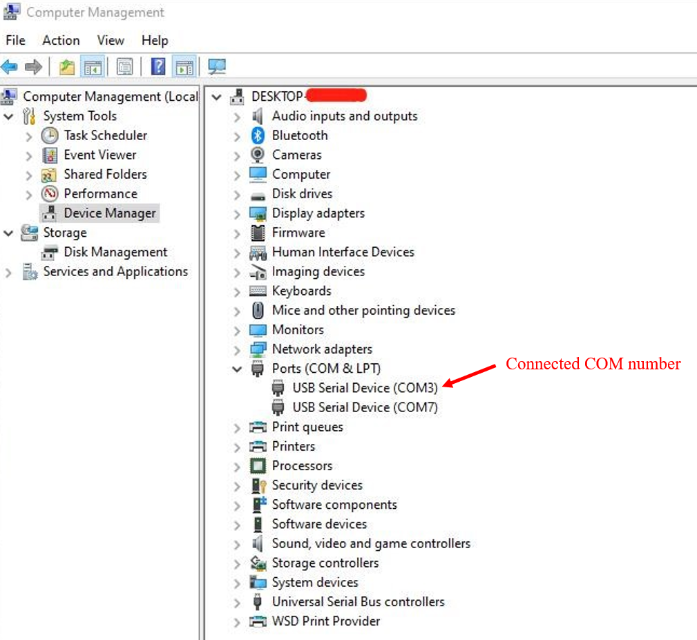

Fig.1 Device port selection

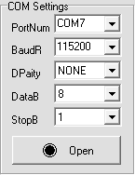

Fig.2 COM setting

After setting up the Serial Port, users can access the laser control panel to read laser data and control the laser device.

1. **Chapter 2 Laser Control Panel**
   1. **Read laser status from serial port.**

The laser is sending its status through the serial port every 0.33 seconds. The format of the data is shown below:

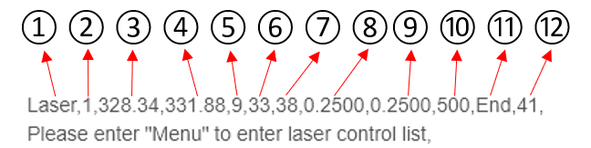

The data type is String. The whole data string consists of 12-character strings, separating by commas. Users may need to do data type conversion when using these data. The meaning of each number is following:

① and ⑫: Data start and data end symbols. The valid data is following when the serial port reads the character string “Laser”.

②: Laser emission status. 1 represents the laser emission is on, 0 means off.

③: Laser working current, unit mA.

④: Laser working power, unit mW.

⑤, ⑥, and ⑦: Laser total service time. Format: hour, minute, second.

⑧ and ⑨: Laser running parameter 1, and 2.

⑩: Laser maximum output power. This value can be set in the control panel.

⑫: Checksum. This number can be used to check data validity.

The aforementioned data can be read from the serial port when connects the laser through the USB port every 0.33 seconds.

* 1. **Setup laser through the serial port.**

The laser embedded software provides a text operation interface for the user to control the laser. The text operation interface will appear when the user correctly connects the laser to a computer through a USB port, please see section 1.3 for connection instruction. As mentioned in section 2.1, the laser will send its working status through the USB port with a time interval of 0.33 seconds as shown in Fig.3.

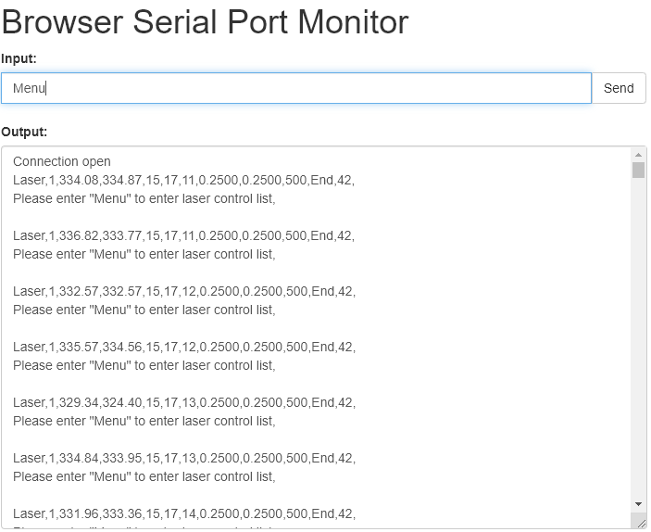

Fig.3 Laser is sending working status

Then the user can access the text operation interface via typing “Menu” through the serial port, as shown in Fig.4.

Note:

* + - 1. The format of the laser acceptable commands is command\r\n. Most of the serial port monitors added a carriage return (\r) and a newline (\n) automatically when the user sends character strings through the serial port, however, some are not. Please try to add a \r\n after the sending string if the laser does not react to the sending commands.
      2. Laser control commands are case sensitive.

The laser control panel provides 9 options. Users can enter a function by sending the corresponding number.

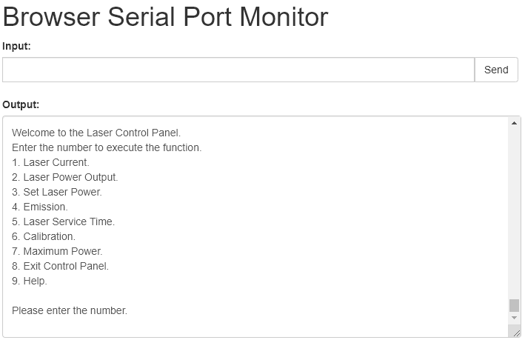

Fig.4 Text operation interface

1. Read laser working current. The user can read the laser working current through the serial port every 0.33 seconds, unit mA, as shown in Fig.5. Enter “Exit” to return to the main menu.

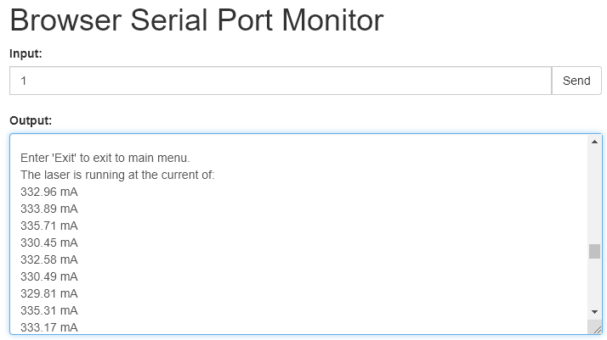

Fig.5 Laser working current

1. Read/set laser working power. The user can read the laser working power through the serial port every 0,33 seconds, unit mW, as shown in Fig.6. Enter “Exit” to return to the main menu.

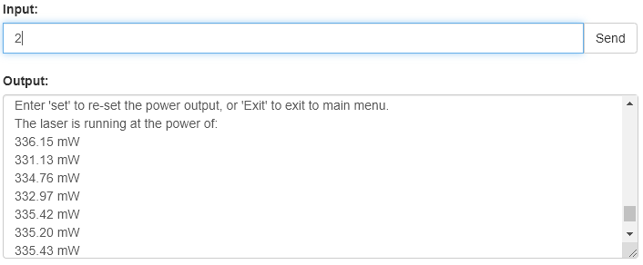

Fig.6 Laser working power

In addition, the user can also setup the laser output power under this option by typing “set”. As shown in Fig.7, the user can input any integer number between 0 and the laser rated power.

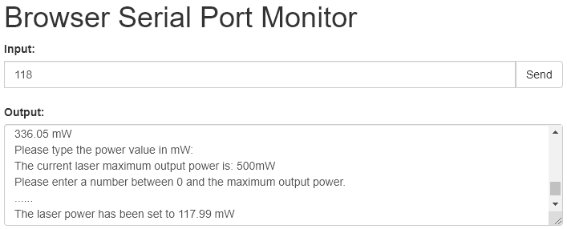

Fig.7 Setup laser working power

1. For user’s convenience, the power setup function has been separated to option 3. Users can set the laser output power by typing 3 directly.
2. Laser emission, which controls the laser emission status, as shown in Fig.8. When the user enters this function, the program will first show the current laser emission status, then the user can close the laser emission by sending “0” or “off”, open the laser emission by sending “1” or “on”.

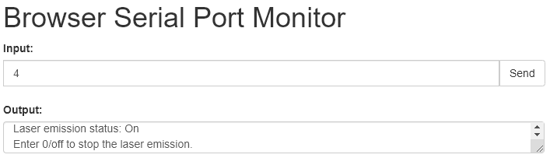

Fig.8 Laser emission status

1. Function 5 returns the laser total service time every 0.33 seconds, which has the format of Hour:XX Minute:XX Second:XX, as shown in Fig. 9. Enter “Exit” to return to the main menu.

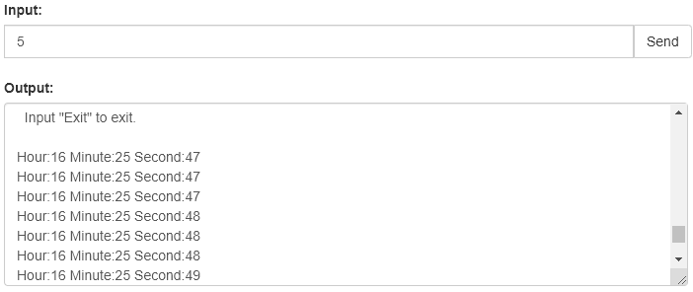

Fig.9 Laser service time

1. Enter 6 to calibrate the laser output power. As shown in Fig. 10. This function must be used with a power meter, and the calibrated value must between 0 and the rated output power. We usually calibrate the laser at its 70% of the maximum output power.

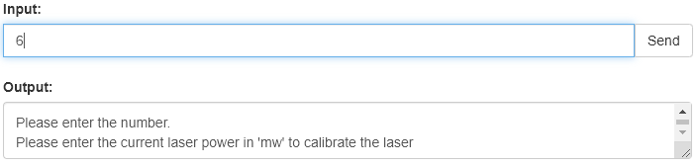

Fig.10 Output power calibration

1. Function 7 allows the user to set up the maximum output power as shown in Fig. 11, unit is mW. Please read the laser rated output power to set up this value. Over the rated output power may lead to inaccurate output power.

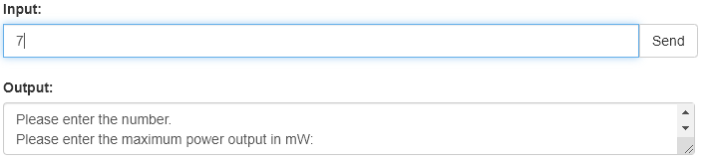

Fig.11 Setup the maximum output power

1. Exit the laser control panel to return to the laser status read windows shown in Fig.3.
2. The help function gives brief instruction to each of the options, as shown in Fig. 12. Enter the corresponding number to read the brief description of each option.

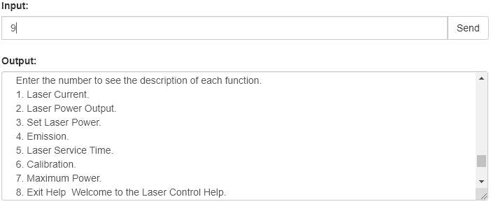

Fig.12 Laser help

**Chapter 3 Command-based Control**

Users can control the laser by entering commands through the serial port directly with a specific format. The format is {command} or {command parameter}. All the commands and their function description are shown in Table 1.

Table 1. Laser Control Commands

|  |  |  |
| --- | --- | --- |
| Function | Description | Return |
| {lason} | Turn on laser emission | N/A |
| {lasoff} | Turn off laser emission | N/A |
| {getpower} | Read laser working power | Power in mW |
| {readset} | Return the set output power | Power in mW |
| {hour} | Get the laser service time | Time in hour |
| {getcal} | Read calibration parameters | Current parameter/Power parameter |
| {setpower X} | Set laser output power to XmW | Succeed/Failed |
| {cal X} | Calibrate output power to XmW | Succeed/Failed |
| {setpowerMax X} | Set the maximum output power to XmW | Succeed/Failed |

**Chapter 4 Laser Controller on Windows**

We also provide the windows application for multiple laser devices monitoring and control, running on Windows XP and above, which is shown in Fig.13. This Windows application can monitor and control 4 laser devices at the same time.

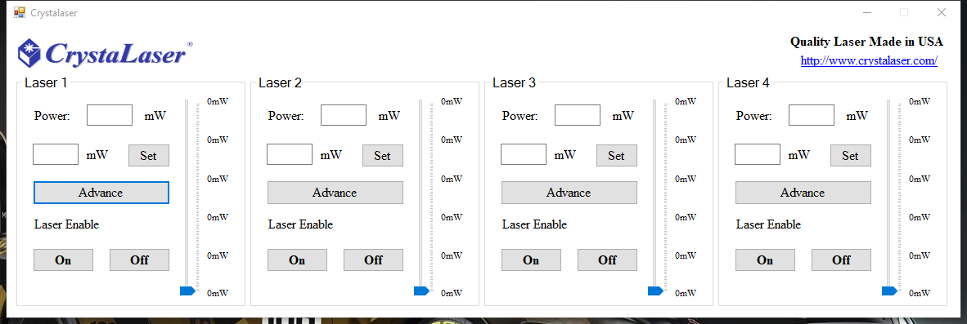

Fig.13 Laser controller on Windows

* 1. **Connection.**

The laser connection function has been moved to the Advance. Click the “Advance” button on the main interface. In the pop-up window, as shown in Fig.14, the user can select the COM and baud rate. The baud rate defaults 115200. Then simply click “Open COM”, the connection between the laser and the computer is established. Click “Close the COM” to disconnect the laser.

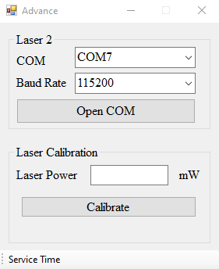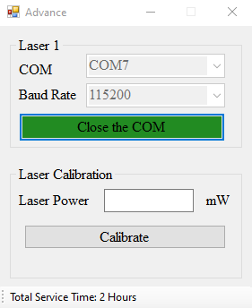

Fig.14 Advance

In the “Advance”, the user can see the laser total service time on the right-bottom of the window.

* 1. **Laser status.**

Users can read laser output power in real-time marked by red rectangular. The laser emission status is printed in the green rectangular. If the laser emission status is on, the user can turn off the emission by clicking the red “Off” button.Otherwise, the user can click the green button “On” to turn on the laser emission.

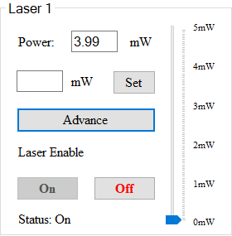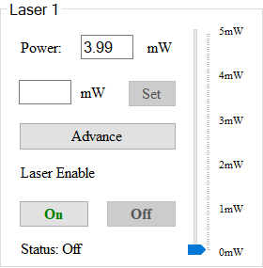

Fig.15 Laser Status

* 1. **Output power setup**

There are two ways to setup the laser output power as shown in Fig.16. First, enter a valid number to the text box of the blue rectangular, and then click the button “Set”. The valid number must between 0 and the maximum power output.

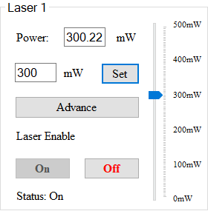

Fig.16 Laser output power setup

The second way to adjust the laser output power is to drag the power bar marked by orange rectangular, then click the button “Set”.

* 1. **Maximum\Minimum power setup**

Users can click the label marked by red to set up the maximum power output. A textbox appears, enter a valid number, then press the enter key on your keyboard. The maximum output power setup is done. Users can set up the minimum output power in the same manner. Click the label marked by blue rectangular, a textbox appears, enter a valid number, press the enter key on your keyboard. The scale of the power bar will change as shown in Fig.16.

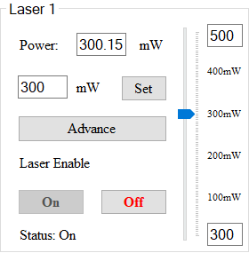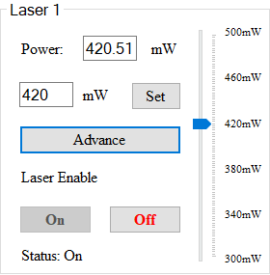

Fig.16 Maximum\Minimum power setup

* 1. **Power calibration**

Laser power calibration is also an advanced function that can be found by clicking the “Advance” button on the main interface as shown in Fig. 17. Enter a valid number in the textbox marked by green rectangular and then click the “Calibrate” button to process. The label “Calibrating…” appears when the calibration is processing. The pop-up window appears and says, “Calibration Done!” when the process is finished, as shown in the right side of Fig.17. Note, the valid number must between 0 and the maximum power output. We usually calibrate the laser at its 70% of the maximum output power.

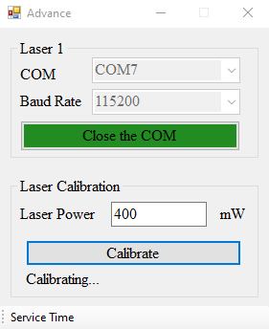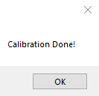

Fig.17 Power calibration